Software Installation.

1. Open below link

<https://visualstudio.microsoft.com/downloads/?cid=learn-onpage-download-install-visual-studio-page-cta>

1. Click on Community Freedownload

1. A close up of a person's face

   Description automatically generated

1. While trying to install if you receive the below alert message click on ‘Continue’

1. After your visual studio installer will be processed for installation in your machine like below

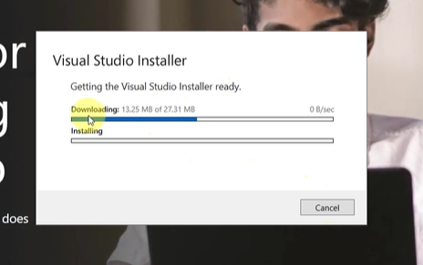

1. Once your installer completed your next popup window will display like below.

1. You have to select the ASP.net and Web development and .net desktop development options from the window like below

1. Once installization is completed click on ‘Install’ button in same window . ‘Install’ button is below of the window like below.

1. Now your visual studio installer installation will be processed like below. So this installer will give you the visual studio community 2022 software in your machine.

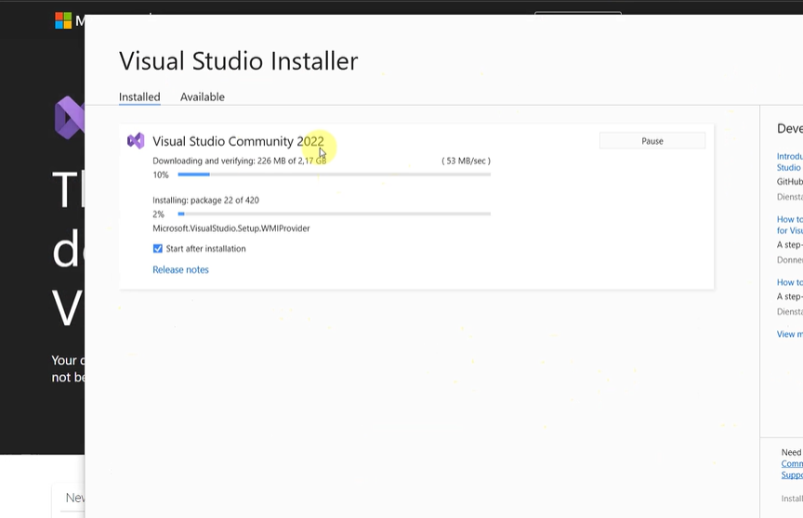

1. Once download completes you will receive below window . Here click on ‘Launch’ button . And follow the below steps.

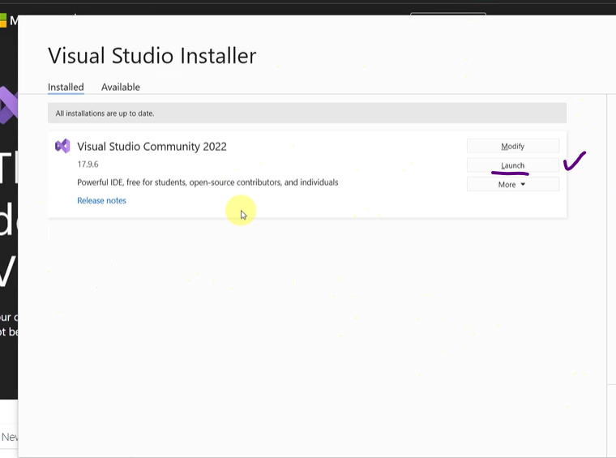

1. Click ‘skip for now’

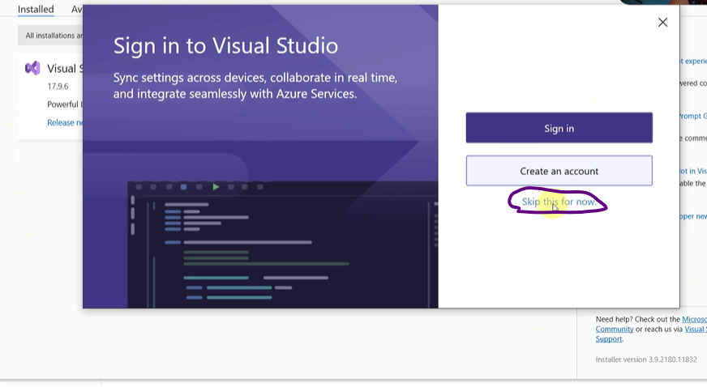

1. Start Visual studio.

